BODHI Australia President’s report 2016 Dr Devin Bowles
2016 has been difficult for the world. Populist rhetoric based on exclusion and xenophobia characterised a number of major elections globally, and has arguably become more prominent in Australia. In this time of growing indifference to the humanity of others and deepening inequality, BODHI’s work is especially important.
In a world of so much suffering, we need our hearts to be softened by compassion. Yet in a world so complicated by the machinations of those motivated primarily by their own self-interest, we need our compassion to be skilful and discerning. These principles have guided BODHI in our work in this last year.
The work of Jeevak has been a source of light and inspiration in Pune, India. In 2016, BODHI’s funds to Jeevak were used for a crèche, including early education and nutritional supplements for 29 young children, overseen by two women. We also pay the rent, associated running costs and other things such as outreach to the parents. These children live in a slum in Pune, where families have been driven to settle for a variety of reasons, including drought.
Similarly, BODHI supported important work of Moanoghar, in the Chittagong Hill Tracts of Bangladesh. This includes education, health promotion, mobile health clinics, three Denis Wright Memorial Scholarships to female students in the last year and subsidies for 3 especially deserving students.
The work of Jeevak and Moanoghar has been coupled with a high standard of reporting back to BODHI, which helps ensure that donations to BODHI are wisely spent.
BODHI also supported SNEHA in Arunachal Pradesh in India, from 2005-2016 to provide education to the Chakma and other communities which reside there. BODHI’s goal is always to make itself redundant, and to help an organisation or community grow to the point where BODHI’s assistance is no longer required. SNEHA received a large grant from another source in 2016. At the same time, the Executive felt that recent decisions in SNEHA’s governance spoke to a philosophical divergence between BODHI and SNEHA, and decided to invest our limited funds in other projects.
The project most recently funded by BODHI has been the support of 50 training scholarships by the Aryaloka Education Society in Nagpur, India. About 70% of these have been for young women, who can face substantial discrimination. Educational topics include English, IT, and a range of others.
BODHI’s successes are the work of many people. Let me take thank my fellow office bearers, committee members, the public officer, and community advisers. Other supporters whose help has been invaluable include Maxine Allan who does the receipts; Conrad Richter who set up the online data base; our accountant Greg Harper; Bryan West, for his advice and financial contributions; and Charles Chadwick, for use of his photos on the website. Thanks are also due to Lucia Arman. Our donors are critical to our work, as are our advertisers, especially Biodistributors. Special thanks are due to the late Mrs Sygma Warren for her generous bequest. Our well-wishers, social media supporters (all of those who “like” us on Facebook) help spread our message. Aryadharma and the Sydney Buddhist Centre provided us with a venue for our AGM. BODHI remains poorer for the loss of its past president, Susan Woldenberg Butler.

BODHI Australia financial report for 2016 calendar year
Colin Butler treasurer
This supplements the auditor’s report, prepared by Camerons Accountants, Launceston Tas and received (after an adjustment) on May 5, 2017.
Main points:
- Donations fell by 45%, but adjusted for removal of the “piggyback” role for Bodh Gaya Development Association and Red Kangaroo in India the fall is not as steep: 33%
- This no doubt reflects Susan’s loss, supporter doubt that BODHI can continue, and fewer and less regular newsletters (due to Susan’s death and reinforcing the doubt).
- Advertising (Biodistributors) fell from $6,000 to $4,000, due to an economic downturn for them; they remain very supportive. A few generous donors have retreated, not all though.
- Bank interest declined from about $5,700 to about $3,400 due to the falling interest rates
- Colin repaid $2,000 inadvertently over-paid for 2015 travel; this is counted as 2016 income.
- The accountant recommended we value our posters – at $1,000. We still have at least 100, mostly in Tasmania.
- As expenses rose and income fell, our end year total balance declined, but was still very healthy– almost $150K. This is sufficient to meet existing commitments for several years, even if we stopped trying to raise funds or they fall to a tiny trickle. Our closing balance in 2016 was almost exactly the same as our starting balance in 2015.
- Our ratio of non-project expenses to income fell to less than 3%, irrespective of whether the $2,000 travel repayment is counted as income. This is probably lower than desirable (for discussion, perhaps after AGM). The ratio for 2015 was high and would have been higher without the piggyback income. However, occasional visits to our partners are very important, if possible. We cannot entirely rely on reports or proxies.
- Project notes: Moanoghar funding was delayed until 2016 (due to an error in Bangladesh about the bank number); that is a major reason project costs in 2016 were so much higher than 2015 (especially if the piggybacked projects are excluded).
- Funding for SNEHA has been discontinued due to concerns about its management.
- Instead we started to fund the Aryaloka computer project.
- It is not mainly lack of funds which stops additional projects but lack of oversight capacity and the difficulty of locating partners with FCRA status (or equivalent) whom we can sufficiently trust. (FCRA=Foreign Currency Regulation Act).
- Kabita Chakma did not spend $500 as her project was in the end funded from other sources (She has repaid this in 2017)
- Thanks to our auditor, Greg Harper, at Camerons. Due to a rule change this is the second last time we need to undergo a gruelling audit (collating all correspondence etc) – unless we get much bigger ($150,000 income?).
- All ACNC requirements for 2016 were met by the deadline (see end re acronym).
- All international transfers were done electronically, using ANZ, which has better service than Bendigo. However credit card donations remain with Bendigo, which has a cheaper rate.
 |  | 2016 | 2015
Opening Bank Balance Jan 1 |  | 173,032 | 148,544
Income
Advertising |  | 4,000 | 6,000
Dividends |  | 221 | 221
Donations (all) |  | 21,559 | 49,204
Interest (all) |  | 3,387 | 5,713
repay travel* |  | 2,000**
Total monetary Income |  | 31,167 | 57,138
stock (posters) |  | 1,000
Expenditure
Accountant/auditor |  | 440 | 330
Bank charges |  | 236 | 515
Bank transfer loss |  |  | 2,497
Consultant (wages and travel)
Filing Fees |  | 59 | 59
Printing, postage, stationery |  | 78 | 309
Projects |  | 53,482 | 21,030
Travel (Colin & Aryadharma) |  |  | 7,376**
Adjusted travel |  |  | 5,376**
Website fee |  |  | 532
Total expenditure |  | 54,296 | 32,648
BANK BALANCES
Term Deposit 1 |  | 50,916 | 50,916
Term Deposit 2 |  | 81,407 | 79,304
Others accounts (5) |  | 17,244 | 42,578
Petty Cash |  | 156 | 234
Closing balance 31 December |  | 149,903 | 173,032
inflow-outflow |  | 23,129 | 24489
bank balance change |  | 23,129 | -24488
Projects |  | 53,482 | 21,030
non-project expenses |  | 814 | 9,618
non-project expenses as % of income |  | 2.6% | 16.8%
adjusted ratio |  | 2.8% | 13.3%
PROJECTS | state/country |  |  | 2016 |  | 2015
Aryaloka | Nagpur, Maharashtra, India |  |  | 15,271
Bodh Gaya Development Fund | Bihar, India |  |  |  |  | 9,500
Kabita Chakma | Bangladesh |  |  | 500
Moanoghar | Bangladesh |  |  | 19,929 |  | 100
Red Kangaroo in India | Sarnath School, UP, India |  |  |  |  | 1,650
SNEHA | Arunachal Pradesh India |  |  | 7,093 |  | 1,095
TBMSG (Karunadeepa) | Pune, Maharashtra, India |  |  | 10,689 |  | 8,685
Total |  |  |  | 53,482 |  | 21,030
According to the Australian Charities and not for profits Commission (ACNC) 37% of all Australian charities are classed as “Extra Small”, with less than $50,000 in income. In 2016 we shifted to that category.
Director of Electronic Communications Report
Colin Butler
Activities for the year 2016 and early 2017
Summary
- website
- social media (Facebook and Twitter)
- Mail Chimp, newsletter and receipts
- YouTube videos
Website: has got quite easy for me to do, though I still find some errors. A few people have suggested improvements; thanks to those people. I am still looking for an assistant! However, such a person should really know a fair bit about it, as it would not be too hard to cause severe injuries to the site. I had a code error for Paypal that was highly embarrassing but no one lost money. I hope it is fixed but it gave me a very jaundiced view of Paypal’s service. The BODHI US website increasingly diverges from that of BODHI Australia; I think that is good.
Traffic: according to Google Analytics (GA) (recently established for the Weebly website) we get less traffic than Weebly. I think the Weebly counter is probably more accurate; I probably don’t have the right code for GA on every page (see figures 1 and 2).
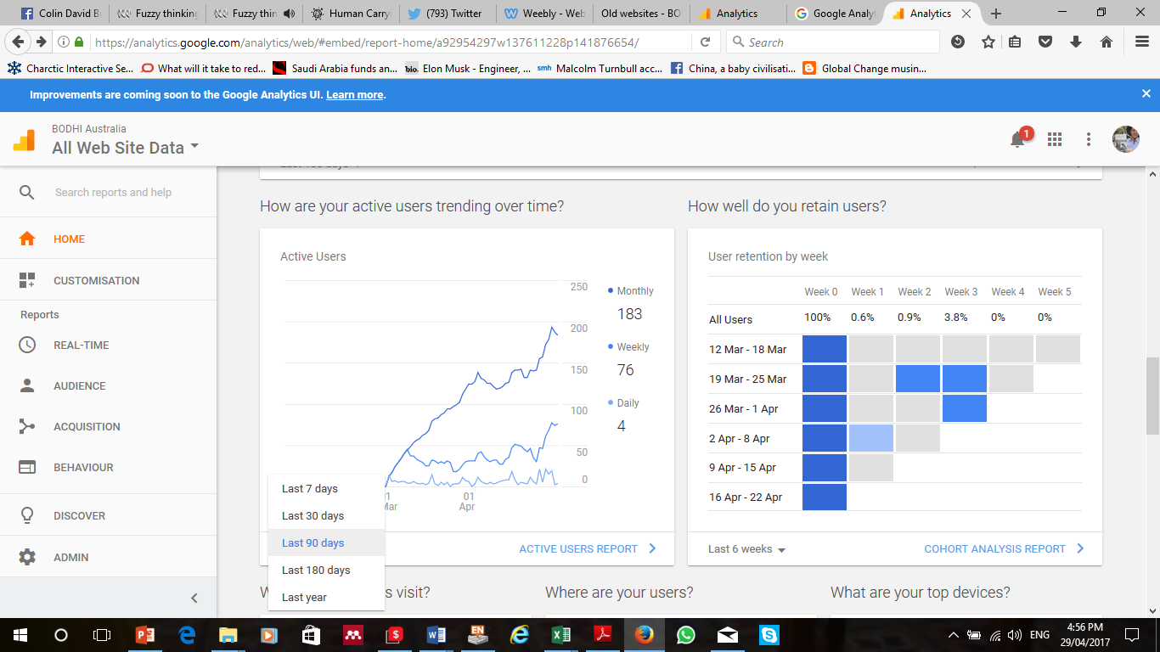
Figure 1 GA data May 2017
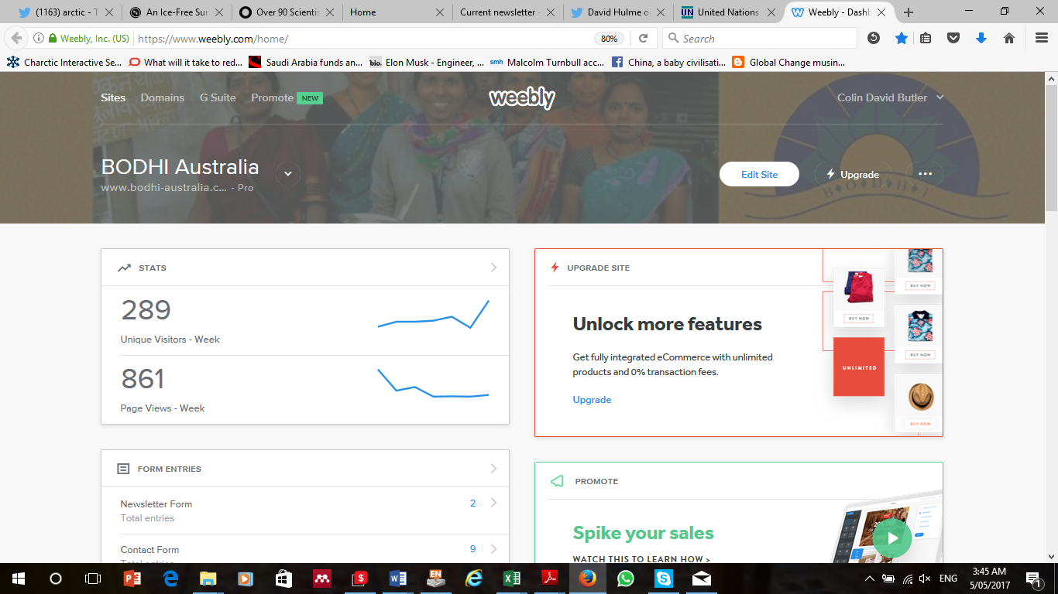
Figure 2 Weebly stats May 5, 2017
Social Media
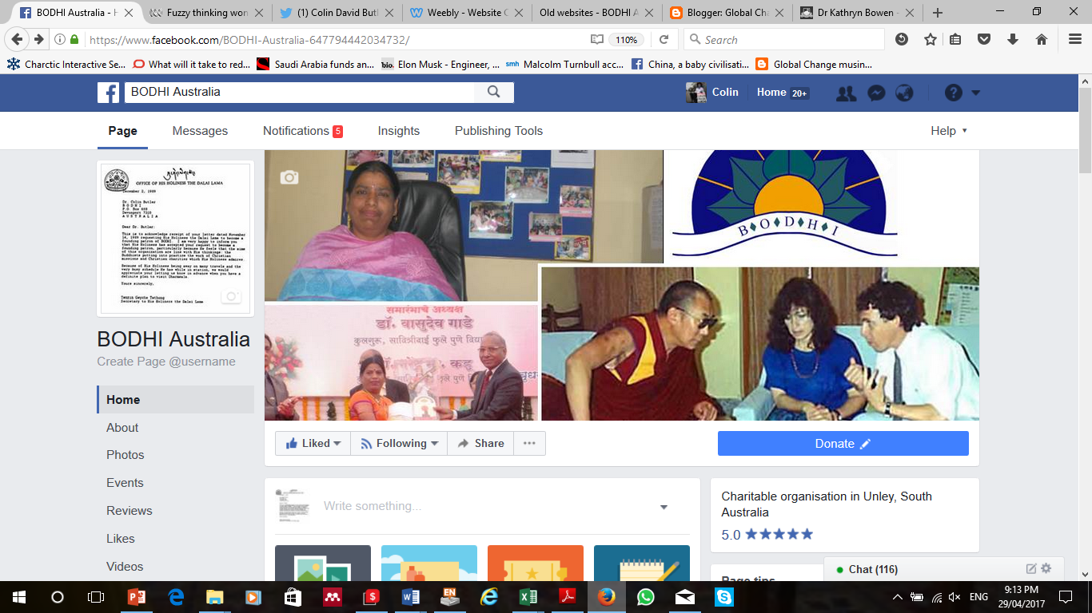
Figure 3 BODHI Australia page header.
Facebook (FB) membership has grown slightly (1,374 as at April 29, 2016); impact is hard to say, so far has not led to a single donation from anyone who has not actually met me. I recently culled about 50 people from the group (all from high income countries), concluding that they were uninterested. However, as Dr Bryan West pointed out, we cannot do without a social media presence. We also established a BODHI Australia FB page with a donate button, with Bryan’s help (see figure 1). Twitter (“BODHI group”) is scarcely used. However, it could be resurrected. Help needed: Entries, likes and retweets on FB, Twitter and other social media: if you have a social media platform, please add BODHI postings or talk about BODHI and our projects.
MailChimp: is now working ok, I think. BODHI Times #50 was extremely laborious, and may be the 50th and last in that format. However, regular communication is vital. I plan a third Mailchimp mailout in early June – hopefully it will attract some donations at the end of the financial year (see figure 4). Help: please suggest email addresses for the mailing list.
Receipts and the register of donors is done mainly by Maxine Allan, thanks, using software provided and maintained by Conrad Richter, who is based in Toronto, Canada.
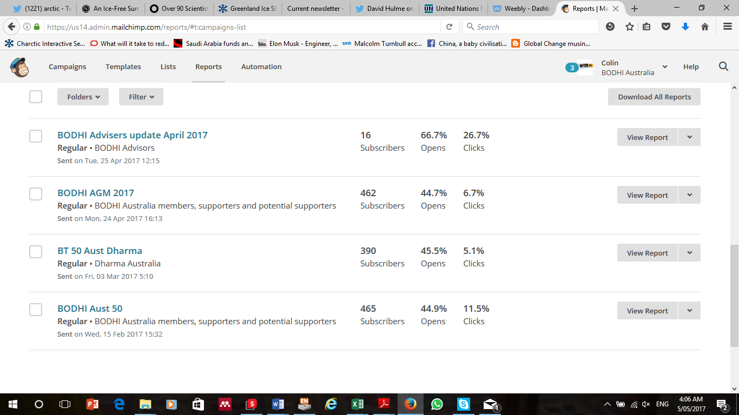
Figure 4 Mail chimp reports: our opens and clicks are much higher than the industry average – but our mailing list is quite selected

